CV (Spring 2021)

Name:

**ORB (Oriented FAST and Rotated BRIEF)**

**This project is worth 200 points.**

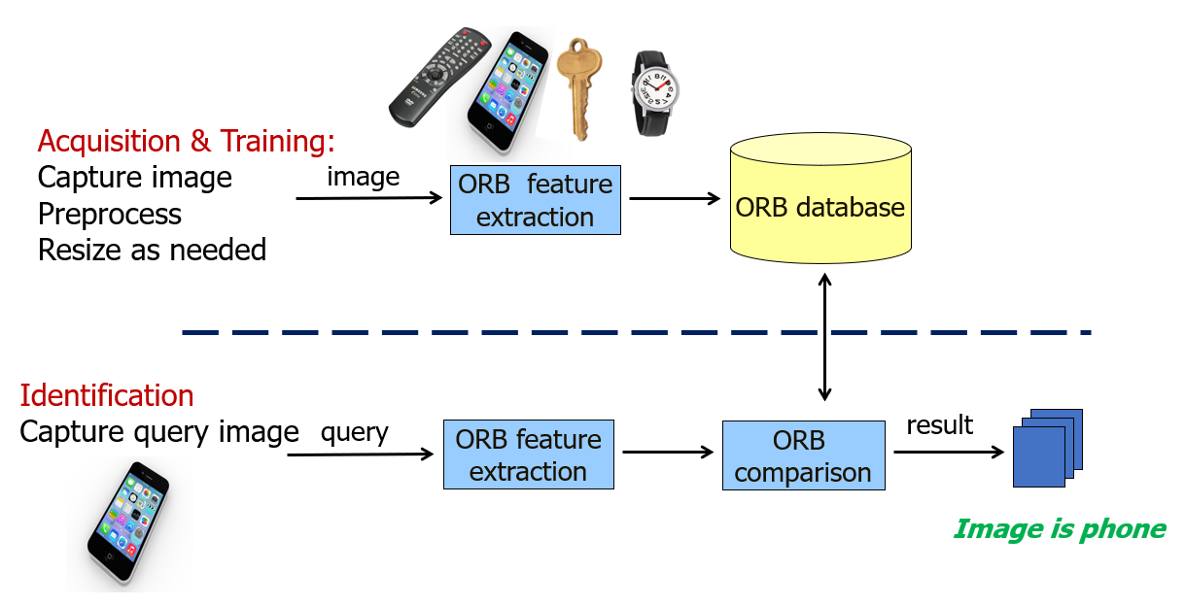

ORB is hailed as a free and efficient alternative to SIFT. In this project, you will use the ORB feature to distinguish among 4 objects: ***a remote control, a phone, a watch, and a key***.

The project will consist of three stages:

* **Acquisition Stage**: In the acquisition stage, you will capture the image of the object to be detected. Capture one image for each object and give it a proper name such as remote_control.jpg, phone.jpg, etc. Store the images in a separate folder. **V**
  + To make things easier for later stages, store all images with a specific size (you can use OpenCV resize functions) **V**
* **Training Stage**: In the training stage, you will extract the feature of each object and store it in a file (remote_control.orb, phone.orb, etc.). Load the files into a data structure so they can be used for classification. features are usually stored in a database, but files are ok for this project.  **V**
* **Classification Stage**: in the classification stage, you will identify an object as one of the 4 objects listed above. Start by capturing the image of the object, extract its feature vector and then compare it against the feature vectors of the objects above. **V**

Check the link at <https://docs.opencv.org/master/d1/d89/tutorial_py_orb.html> to learn how to extract the ORB features.

For matching, check the link at <https://docs.opencv.org/master/dc/dc3/tutorial_py_matcher.html> . This a very simple matcher that should do for this project.

1. Use this project to learn the basics of video capture with OpenCV. <https://docs.opencv.org/master/dd/d43/tutorial_py_video_display.html>
2. Although not required for this project, if you plan to go into the OpenCV area, I recommend learning Tkinter, the GUI part of Python.

Along with the code, please write a **word document *report*** that includes:

* **Cover page**: Title, your name, date. **V**
* **Introduction**: overview of feature extraction, ORB, the project with a diagram **V**
* **Results**: table of objects used, orb features, sample queries **V**
* **Discussion**: how did the project go, compare results, any surprises, accuracy, performance etc. **V**
* **Conclusion**: including future enhancements. **V**

**Grading and Submission Guide:**

* Must submit the whole project (python folder with code, image dataset, and results) zipped using 7zip tools with the name: LastName_FirstName_Project-04. Include the report.
* This is an **individual** project: The work should represent your own: that you acknowledge that have not incorporated into this project any unacknowledged material from the work of another person, including papers, words, ideas, information, computer code, data, evidence-organizing principles, or style of presentation taken from the Internet, books, periodicals, or other sources.